RDS MySQL → S3 Backup Setup
Step 1: Connect to EC2 Server
ssh <your-ec2-ip>

Step 2: Verify RDS Connectivity
mysql -h <hostname> -P 3306 -u admin -p
If it fails:
- Check RDS Security Group (3306 open)
- Check EC2 ↔ RDS network access

Step 3: Install Required Packages
apt update
apt install mysql-client unzip -y
Install AWS CLI
curl "https://awscli.amazonaws.com/awscli-exe-linux-x86_64.zip" -o "awscliv2.zip"
unzip awscliv2.zip
./aws/install
Verify:
aws --version

Step 4: IAM Role Setup (Recommended – No Access Keys)
4.1 Create IAM Role
- Go to IAM → Roles → Create Role
- Select: EC2

4.2 Attach Policy
{
"Version": "2012-10-17",
"Statement": [
{
"Effect": "Allow",
"Action": ["s3:PutObject", "s3:GetObject", "s3:ListBucket"],
"Resource": [
"arn:aws:s3:::server-dmg-rdsdump-backup",
"arn:aws:s3:::server-dmg-rdsdump-backup/*"
]
}
]
}

4.3 Role Name
For. Ex. EC2-RDS-S3-Backup-Role

4.4 Attach Role to EC2
- EC2 → Instance
- Actions → Security → Modify IAM Role
- Select: EC2-RDS-S3-Backup-Role

4.5 Verify Role on Server
aws sts get-caller-identity
Expected:
assumed-role/EC2-RDS-S3-Backup-Role
Step 5: Create Backup Directory
mkdir -p /home/root/backups

Step 6: Create Backup Script
nano /home/root/rds_hourly_backup.sh
Paste this final clean script:

#!/bin/bash
set -e
PROJECT="adnec-web-uat-rds"
RDS_ENDPOINT="adnec-web-uat-rds.cdwvyxgq0egr.ap-south-1.rds.amazonaws.com"
DB_USER="admin"
DB_PASSWORD="YOUR_PASSWORD"
S3_BUCKET="server-dmg-rdsdump-backup"
BASE_DIR="/home/root/backups"
LOG_FILE="/home/root/backup.log"
DATE=$(date +%F)
HOUR=$(date +%H-%M)
FILE_NAME="full_backup_${HOUR}.sql.gz"
BACKUP_DIR="$BASE_DIR/$PROJECT/$DATE"
mkdir -p "$BACKUP_DIR"
exec >> "$LOG_FILE" 2>&1
echo "=============================="
echo "Backup Started at $(date)"
# Disk check
AVAILABLE_SPACE=$(df /home | awk 'NR==2 {print $4}')
if [ "$AVAILABLE_SPACE" -lt 1048576 ]; then
echo "Low disk space! Backup aborted."
exit 1
fi
# Dump
mysqldump -h "$RDS_ENDPOINT" \
-u "$DB_USER" \
-p"$DB_PASSWORD" \
--all-databases \
--routines \
--triggers \
--events \
--single-transaction \
--skip-lock-tables \
--set-gtid-purged=OFF \
--quick \
| gzip > "$BACKUP_DIR/$FILE_NAME"
echo "Dump Completed"
# Upload to S3
if aws s3 cp "$BACKUP_DIR/$FILE_NAME" \
"s3://$S3_BUCKET/$PROJECT/$DATE/$FILE_NAME"; then
echo "Upload Successful"
else
echo "Upload Failed"
exit 1
fi
# Cleanup
rm -f "$BACKUP_DIR/$FILE_NAME"
echo "Backup Completed at $(date)"
echo "=============================="

Step 7: Give Permission
chmod 700 /home/root/rds_hourly_backup.sh

Step 8: Test Backup Manually
/home/root/rds_hourly_backup.sh

Step 9: Check Logs
cat /home/root/backup.log
You should see:
- Backup Started
- Dump Completed
- Upload Successful

Step 10: Verify in S3
aws s3 ls s3://server-dmg-rdsdump-backup/adnec-web-uat-rds/ --recursive

Step 11: Setup Cron Job (Hourly Automation)
crontab -e
Add:
0 * * * * /home/root/rds_hourly_backup.sh >> /home/root/backup.log 2>&1

Step 12: Setup Log Rotation
nano /etc/logrotate.d/rds-backup
Paste:
/home/root/backup.log {
daily
rotate 7
compress
missingok
notifempty
copytruncate
}

Final Flow (Simple Understanding)
- Every hour cron runs script
- Script takes dump from RDS
- Compresses it
- Uploads to S3
- Deletes local file
- Logs everything

Cross-Region S3 Replication (Mumbai → N. Virginia)
Step-by-Step
🔹 Step 1: Enable Versioning (MANDATORY)
Do this FIRST (very important)
For Source Bucket:
- Go to S3 → hindavidbbackupnew
- Click Properties
- Scroll to Bucket Versioning
- Click Edit
- Enable → Save
STEP 2: Create Destination Bucket (N. Virginia)
Go to:
- AWS Console → S3
- Click Create bucket

Fill Details:
Bucket Name:
hindavidbbackupnew-dr
Region:
Select:
US East (N. Virginia) us-east-1
Keep Default Settings:
- Block Public Access → Enabled
- Versioning → (we will enable later)
- Encryption → Default (SSE-S3)
Click Create bucket

STEP 3: Enable Versioning (VERY IMPORTANT)
🔹 For Source Bucket (Mumbai)
- Go to: hindavidbbackupnew
- Click Properties
- Edit → Enable Versioning
- Save

🔹 For Destination Bucket (N. Virginia)
- Open: hindavidbbackupnew-dr
- Go to Properties
- Enable Versioning
- Save

STEP 4: Create Replication Rule
Go to:
- Source bucket: hindavidbbackupnew
- Tab: Management
- Scroll → Replication rules
- Click → Create replication rule

STEP 5: Configure Rule
Rule Name: rds-backup-replication
- Scope: Prefix (dwtc-)(change to all objects)for another server
- Destination: hindavidbbackupnew-dr
- IAM Role: Auto-created (s3crr_role_for_hindavidbbackupnew)

Step 6: Disable Delete Marker Replication(If file deleted in source → should delete in destination)
Ensures:
- Deleted backups in source
→ also deleted in destination
Step 7: Replicate Existing Data
Created Batch Replication Job
Selected:
- Replicate existing objects
- Automatically run job

Final Replication:
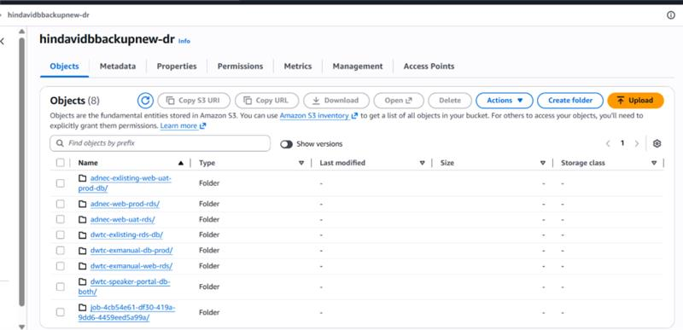

Lifecycle policy:
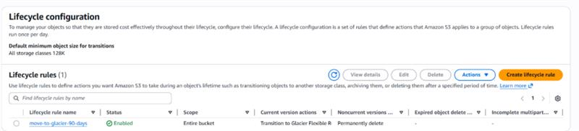
Apply Lifecycle Rule on Destination Bucket (hindavidbbackups-dr)

Objective
- Move replicated backups to Glacier after 90 days
- Automatically delete backups after 365 days

🔹 Step 1: Open S3 Console
Go to:
AWS Console → S3

🔹 Step 2: Open Destination Bucket
Open bucket:
hindavidbbackups-dr
(Your N. Virginia DR bucket)

🔹 Step 3: Open Management Tab
Inside bucket:
- Click Management
- Scroll to:
Lifecycle rules
- Click:
✅ Create lifecycle rule

🔹 Step 4: Enter Lifecycle Rule Name
Example:
move-to-glacier-90-delete-365

🔹 Step 5: Choose Rule Scope
Select:
✅ Apply to all objects in the bucket
Then enable:
✅ I acknowledge that this rule will apply to all objects in the bucket

🔹 Step 6: Select Lifecycle Actions
Under:

Choose lifecycle rule actions
Select:
✅ Transition current versions of objects between storage classes
✅ Expire current versions of objects

🔹 Step 7: Configure Glacier Transition
Under:

Transition current versions of objects between storage classes
Configure:
Setting | Value
Storage Class | Glacier Flexible Retrieval
Days after object creation | 90
Meaning:
After 90 days → Move backups to Glacier

🔹 Step 8: Configure Auto Delete
Under:

Expire current versions of objects
Configure:
Setting | Value
Days after object creation | 365
Meaning:
After 365 days → Automatically delete backups

🔹 Step 9: Review Final Configuration
Your lifecycle policy should look like:
Day 0 → Backup stored in Standard S3
Day 90 → Automatically move to Glacier
Day 365 → Automatically delete backup

